CSA1708-ARTIFICIAL INTELLIGENCE
LAB EXPERIMENTS
Program 15 : Python Program to Implement Decision Tree
Aim
To develop a Python program to implement the Decision Tree classification algorithm (ID3) using Entropy and Information Gain to construct an optimal decision tree from a dataset.
Algorithm
1. Define the training dataset comprising categorical attributes and a binary target classification (e.g., PlayTennis).
2. Define a function to calculate the Entropy of a dataset based on target class distribution: Entropy(S) = -sum(p_i * log2(p_i)).
3. Define a function to calculate Information Gain for a candidate splitting attribute: Gain(S, A) = Entropy(S) - sum((|Sv|/|S|) * Entropy(Sv)).
4. Define the recursive ID3 tree-building function:
5. a. If all examples in the subset have the same target classification, return that single leaf label.
6. b. If the attribute list is empty, return majority target label in current subset.
7. c. Otherwise, calculate Information Gain for every remaining candidate attribute.
8. d. Select the attribute with maximum Information Gain as the decision node.
9. e. For each distinct value of the selected attribute, split dataset and recursively build child subtree.
10. Build complete decision tree starting from full training set.
11. Display computed Entropy, Information Gain for attributes, and constructed Decision Tree root split.

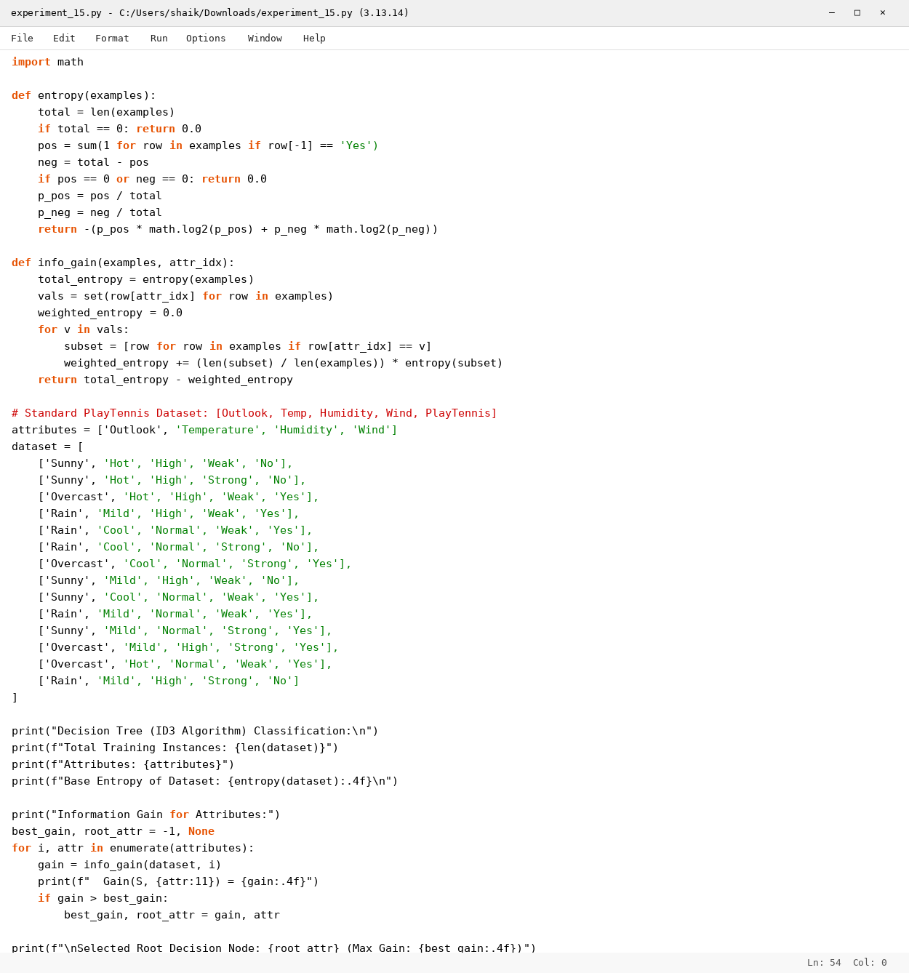

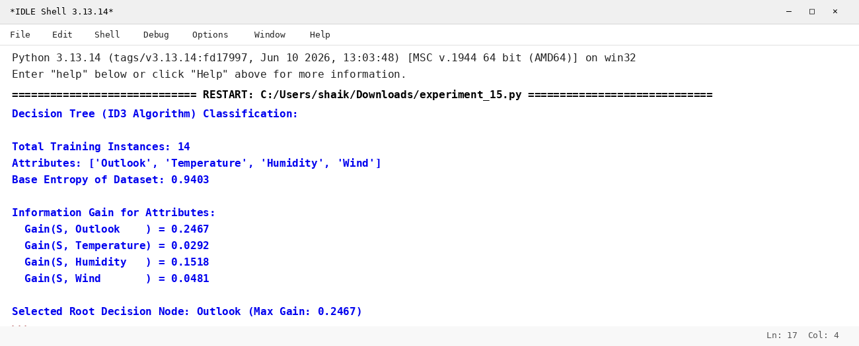

RESULT
Thus, the Decision Tree algorithm was implemented successfully using Python.

